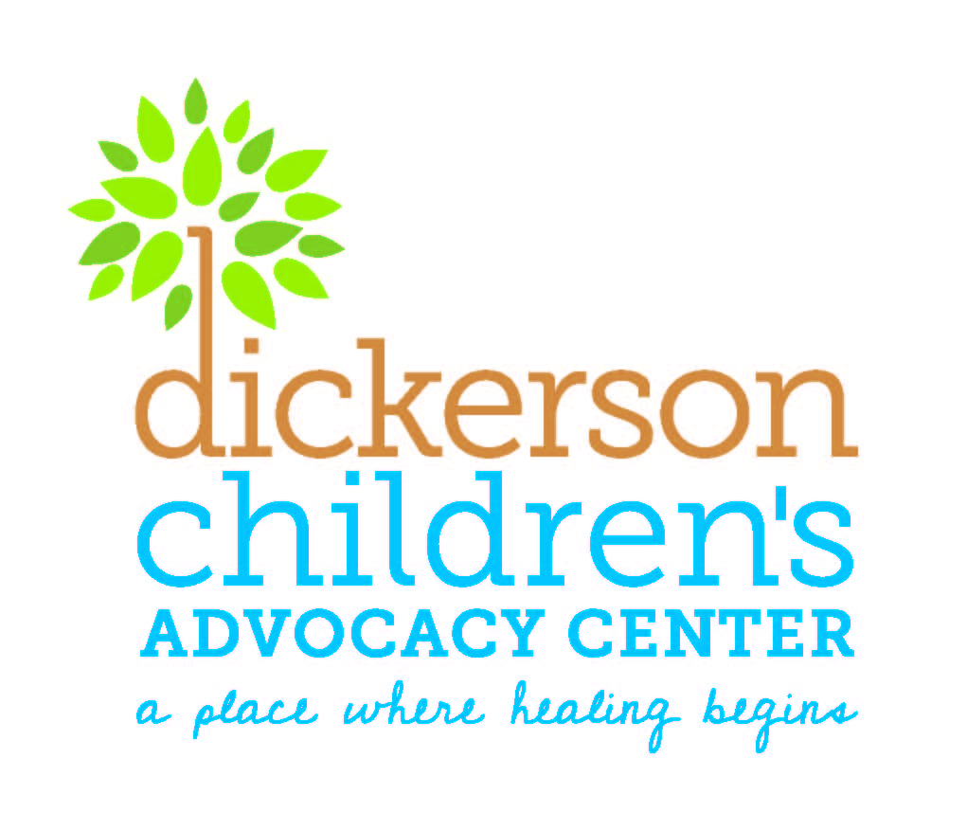

1615 Augusta Highway, West Columbia, SC 29169
PHONE: 803.791-1511
EMAIL: dickersoncenter@dickersoncac.org
WEBSITE: www.dickersoncac.org

Donation Wish List:

White-out/correction fluid
Goldfish food
Thank you cards
Copy paper
Paper towels
Toilet Paper
Clorox Wipes
Lysol Spray
Hand soap
Hand sanitizer

Individually wrapped snacks
Juice Boxes & 8 oz / 4 oz bottles of water
Scrapbook stickers
Postage stamps
Trash bags (45 gallon)
Plastic spoons and/or forks
Disposable Plates and Bowls
Disney or Pixar DVD’s (“G” Rated)
Easel Pad 17 x 20 inches
DVD-Rs & Paper Sleeves (no plastic please)

Gift Cards (Amazon, Walmart, Dollar General)
50 sheets of premium heavy weight white bond paper
Gently loved toys and books
New Barbie dolls & Barbie accessories
Kid specific craft kits
Sand Tray (Amazon Wish List)
Playdough
Markers (washable)
Pipe Cleaners
Balloons
Spray air fresheners

**DCAC has (2) wish lists at Amazon.com, please search for “Dickerson Center” to locate
*Please check expiration date to ensure all food & drink products will remain fresh for at least 2 months

Because space is limited, we are currently NOT ACCEPTING the following items:
- Clothes
- Shoes
- Toiletry items
- Stuffed animals
- Outdated software/hardware technology

Please take a moment to call DCAC before delivering your considerate donations.
Thank YOU for YOUR support!

